Floyd Henson Junior High School

Effective: August 1, 2023

Flora High School

Athletic Handbook
FLORA CUSD #35

2023-2024

Table of Contents

I. Flora CUSD #35 Handbook for Athletic Activities
Statement of Philosophy 3
Dropping a Sport 3
Team Rules………………………………………………………………………… 3
Athletic Attendance Policy………………………………………………………………………………….3
Athletic Rules and Regulations 3
Criminal Activity 3-4
Sequence of Punishment 4
Drug Testing (Extracurricular Random & IHSA) …………………..……………. 5
Validation …………………………………………………………………………. 5
Transportation to and from Athletic Contest 5
Right to Review 6
Academic Eligibility 6
Grade Level Participation 6-7
Parent/Athlete/Coach Communication Guide…………………………………… 7-8
The Sportsman’s Creed………………………………………………………….. 8-9
Before Practice Begins 9
If you think your child has suffered a concussion 10
Symptoms and Signs of a Concussion 11
Testing Policy 12

II. Flora CUSD #35 Participation Agreements
Student Insurance Waiver……………….……………………………………….. 13
IHSA Sports Medicine Acknowledgment & Consent Form 14
Student Athletic Contract 15
Emergency Information and Parent Consent Form ……………………………… 16

Disclaimer

The Handbook is not all inclusive in that it cannot possibly address all the possible scenarios that may arise and still be a convenient and understandable guide for students and parents. The Board of Education does not intend to limit its ability nor the ability of its administrators or faculty to respond to situations that are not specifically addressed herein.
Flora Unit #35 School District
Athletic Handbook

Starting August 8, 2001 rules contained in the Flora Athletic Handbook will be in effect for 12 months a year.

Statement of Philosophy

To establish athletic programs that excel in all areas to provide a variety of activities to enhance the educational program, and to help meet the statements contained in the Flora CUSD #35 policy. This handbook pertains to all CUSD #35 athletic teams. This policy coincides with all other school policies.

Dropping a Sport

If a student should decide to drop a sport, he/she should discuss the circumstances with the coach. Students generally are not reinstated and will not receive an award for participation in the activity. Injury or illness, which results in the student’s inability to finish the entire season, is not considered as dropping the sport. A season consists of the regular season and post season play. All equipment must be returned to the coach as soon as possible.

Athletic Attendance Policy
The attendance policy for student athletes is consistent for all sports at the junior high and high school level. Any student athlete that has one, two, or three unexcused absences will be disciplined according to the team rules for that sport (i.e. extra conditioning, sitting out a game, etc.). Any student athlete that has four unexcused absences will be removed from the team for that season. Questions regarding whether an absence would be excused or unexcused should be directed to the district athletic directors. The district athletic directors will make the final determination on whether an absence is excused or unexcused.
A student athlete that is attending an out of state military ceremony for an immediate family member will be granted an additional three absences for this event. Immediate family member is defined as parents, stepparents, brothers, sisters, grandparents, aunts, uncles, or legal guardian.

Violations of Team Rules
Coaches shall distribute team policies and codes of conduct expected of their players. Coaches will define punishments for various team violations. In all discipline cases, listed in their team rules or not, coaches will discipline as they see fit. Whenever necessary the administration will be consulted for additional punishment.

Athletic Rules and Regulations

Use or possession of tobacco products is prohibited. Consumption, possession or association with alcohol, or illegal drugs or cannabis or drug paraphernalia is prohibited. Illegal drugs would also include synthetic drugs, inhalants, mind altering substances, intoxicating compounds, illegal use of prescription drugs or any items which are not for human consumption.

Association is defined as remaining at an event or situation after having knowledge that “illegal” consumption and/or possession of alcohol, or illegal drugs or cannabis are present.

Each case will be reviewed by a committee consisting of the Principal/Assistant Principal, Athletic Director, and a member of the FHS or Junior High coaching staff.

Criminal Activity

Students who engage in any criminal activity may be denied participation. Recognizing the varying degrees of the severity of the violations (misdemeanors vs. felonies), consequences for such involvement will result in a reprimand or denial of participation, depending upon the nature of the offense.

Each case will be reviewed by a committee consisting of the Principal/Assistant Principal, Athletic Director, and a member of the Unit #35 coaching staff.

Sequence of Punishment

Offenses, which occur between seasons or off-season, will be acted upon in the next season in which the athlete participates. (The athlete must finish the sport in which the punishment is served .)

Suspensions will be served consecutively beginning with the next contest played. Percentages apply to the sport in which the infraction is served. No portion of the uniform shall be worn during the period of suspension.

First Offense

A. Conference with head coach, athletic director, assistant principal, and/or principal.

B. Tobacco: The athlete will be suspended a minimum of 20% of the regular scheduled games in the activity in which the incident occurs.

C. Alcohol/Drugs: The player will be suspended a minimum of 50% of the regular scheduled games in the season in which the incident occurs. In addition, the athlete is expected to seek and participate in counseling. During the initial counseling session at least one parent/guardian must attend this session with their student athlete. If the athlete does not participate in recommended counseling, the penalty will be increased to 75%.

Second Offense

A. Conference with head coach, athletic director, assistant principal, and/or principal.

B. Tobacco: The player will be suspended a minimum of 50% of the regular scheduled games in the activity in which the incident occurs.

C. Alcohol/Drugs: The player will be suspended a minimum of 365 days. In addition, the athlete is expected to seek and participate in counseling.

Third Offense
The player will be suspended, at the minimum, an additional 365 days. After serving, at least an additional 365 days, reinstatement in athletic programs are subject to conditions established by coach and administration.

Note: All penalties carry over from each sport until the penalty is served. Any penalty carryover will be adjusted proportionately in subsequent seasons. If penalties at the junior high level have not been completely served, the penalty will need to be completed at the high school.
However, a new record of offenses, beginning with the first offense, will begin at the high school level. Penalty will not include academic ineligibility or absenteeism.

Note: These rules and regulations should be considered as minimums for each sport. Head coaches may have additional requirements for the sport or activity. Violations could result in penalties being served during the next school year.

Extracurricular Random Drug Testing
In order to participate in sports at Flora High School, all student-athletes and their parents must sign the Informed Consent and Consent to Testing forms. These forms are in a separate pamphlet which may be picked up in the office or from the athletic director. These forms must be filled out and on file before participation will be allowed in any contests.

IHSA Drug Testing
The IHSA will be testing for performance enhancing drugs in the state series contests. Flora High School will follow all guidelines provided by the Illinois High School Association in reference to the new drug testing policy for state series athletes.

Validation
Self-admission, information from faculty, law enforcement authorities, written or pictorial information, postings on blogs or social networking, etc., or any form of irrefutable evidence shall be considered valid.

Transportation to and from Athletic Contest

All students are expected to use authorized transportation when participating in athletic activities held away from Flora Community School District #35. Any exceptions must be approved by Administration.

Guidelines:

1. All students participating in school events such as athletic contests at out-of-town locations must use school transportation to and from the events. (Some unusual exceptions may occur and should be arranged in advance by parents with the coach and approved by the AD/principal.) In addition, the Junior High Coaches may allow students to ride home with their parents after an athletic event. Written verification is required!

2. High school athletes have the option of riding home with their parents if the head coach plans to stop and eat on way home from a game on a school night. Arrangements must be made prior to the athletic event in the form of a note or a phone call to the FHS administration. (2014 addition)

3. Students riding buses may be picked up and dropped off at prearranged locations. The building principal will designate such locations before extracurricular trips are taken. If parents are not waiting for their child at these locations upon return, buses will return students back to school.

4. FHS Athletes: Any failure to adhere to the policy of riding the bus to and from the event will result in a minimum of a one game suspension. The coach may add additional discipline depending on the severity of the case. The only exception would be prior approval granted by the administration to ride home with a parent.

5. School phones may be used by pupils to notify parents of their return.
Right to Review

The student and their parent/guardian have the right to meet with the coach, athletic director, and principal on issues that would constitute a suspension of the student from their respective sport.

Academic Eligibility

Interscholastic and intramural athletics are available for both boys and girls. Organizational and regulative information will be released by the coaches and high school office as the respective seasons begin.

Selection of members or participants is at the discretion of the coaches, provided that the selection criteria conform to the District’s policies. In order to be eligible to participate in any school sponsored athletic activity, a student cannot be failing more than one (1) course. Any student participant failing to meet academic criteria shall be suspended from the activity for seven (7) calendar days or until the specified academic criteria are met, whichever is longer. Students who are ineligible three (3) times during the duration of the season will be removed as a member of that sport. Coaches may use part of practice time for study sessions while a student is ineligible.

Flora High School students must pass seven (7) classes of high school work per week to be eligible to participate in school sponsored athletic activities. You must have passed and received credit toward graduation for seven (7) credits of high school work for the entire previous semester to be eligible at all during the ensuing semester. Ineligibility will be reported to the parent via the student involved in the activity. Individual coaches and school officials are to inform the student of his/her ineligibility.
Flora Junior High students will be provided with academic requirements based on the SIJHSAA. In order to be eligible to participate in any school sponsored athletic activity, a student cannot be failing more than one (1) course. Eligibility is reviewed on a weekly basis. Ineligibility will be reported to the parent via the student involved in the activity. Individual coaches and school officials are to inform the student of his/her ineligibility.

Junior High School Athletics Grade Level Participation
It is the common understanding that the Junior High Athletic Programs that serve various
grade levels are created for the opportunity for maximum participation and skill development. When more that one level of participation exists (basketball, volleyball), it is the intent to see all athletes participate at their assigned grade level. The only deviations from this practice will be dictated by a.) lack of participants, or b.) an exceptionally skilled athlete.
a) 7th & 8th Grade Basketball: If a team has less than 12 players total, the coaching staff can call up underclassmen in order to make a full bench and practice squad. For example, if a team has only nine seventh graders total, the coaches can hold tryouts to call up a total of three sixth graders in order to get to a full twelve players. Coaches need to request such tryouts by the second Tuesday of the season, unless extenuating circumstances arise later than this date.
b.) If an individual athlete demonstrates consistent superb performance of his/her assigned grade level and it is apparent that the athlete would benefit from enhanced competitive opportunities, the athletic director will facilitate a meeting with the parents of the athlete, the Junior High principal, and two designated coaches. If these participants are in agreement that the athletes has opportunity for future success at a higher level, the athlete may be moved up to the next grade level for athletic competition.
It is assumed that this athlete will find success at the upper level and have the opportunity to play an amount of time comparable to his/her previous experiences at the lower level. However, this group of participants should also use this meeting as a time to determine future fate if an athlete does not experience success at the upper level.
Parent/Athlete/Coach Communication Guide

Our Philosophy

Athletic achievement requires sincere commitment from all athletes, parents, coaches and administrators. For all to be successful, effective communication must occur.

The school athletic department and administration believe strongly in being accessible to parents and supportive of the coaching staff.

We are continually attempting to improve communication with the students and parents. For our programs to be truly successful, it is necessary that everyone understand the focus and direction of the program.

District Expectations
The Flora CUSD #35 Board of Education expects sportsmanship respect, and courtesy from all players, coaches, parents, and spectators. Parents and spectators will refrain from the use of any abusive, profane, or sarcastic comments made toward officials, coaches, our players, or the opposing fans.

A parent or guardian that has a concerns should make an appointment through the athletic director. The coach/assistant coaches are not to be questioned before, during, or following a practice or contest. Team dugouts, benches, and locker rooms are areas for the athletes and coaches only. Parents/guardians and spectators are not permitted in these areas.

Any parent/guardian or spectator that violates these policies may be subjected to discipline from the Board of Education up to a possible exclusion from district grounds, activities, and events for one calendar year.

The Flora Board of Education believes strongly in the merits of a well-rounded, competitive sports program and very much approves of the values, work ethic and many other life lessons that can be obtained by our student athletes from such a program.

Expectations of Parents

A. It is reasonable to expect your child’s coach to inform you of:
1. Schedules and locations of practices and contests
2. His/her coaching philosophy
3. The expectation he/she has for all athletes on the squad
4. What is required to be a part of the team, i.e. fees, special equipment, off-season conditioning, lettering requirements, etc.
5. Known injuries of your child during participation in a practice or contest.
6. Any disciplinary actions resulting in denial of participation

B. Typical concerns of parents that are appropriate to discuss with a coach are:
1. Any unhealthy mental or physical strain you detect in your child at home (especially when it affects his/her academic performance).
2. How you can contribute to your child’s skill improvement and development.
3. Any dramatic changes you detect in your child’s behavior.

Expectations of Coach

A. Discussions with parents that may include:
1. Methods to improve student athletic skills and abilities
2. How the athlete can contribute to team success

B. Assistance from parents in regard to the following:
1. Any specific health or emotional concerns of your son/daughter
2. Notification of any schedule conflicts well in advance.
3. Your commitment to the program in such forms as providing proper nutrition and rest and transportation

C. If you have a concern to discuss with a coach, what procedure should you follow?
1. Make an appointment through the athletic director. Please do not approach the coach after a game.
2. Please do not attempt to question a coach before, during, or following a contest/practice.
3. These times can be emotional situations for both the parent and the coach and this time for conferencing do not promote objective analysis of the situation.
4. Please remember that team dugouts, benches and locker rooms are areas for athletes and coaches only.

D. What should you do if the meeting with the Athletic Director, Coach, and Principal does not result in a resolution to the problem?
1. Call and arrange an appointment with the superintendent.

The Sportsman’s Creed

The Player
1. He/She lives clean and plays hard. He/She plays for the love of the game.
2. He/She wins without boasting. He/She loses without excuses, and he/she never quits.
3. He/She respects officials and accepts their decisions without question.
4. He/She never forgets that he/she represents his school.

The Coach
1. He/She inspires in his/her athletes a love for the game and the desire to win.
2. He/She teaches them it is better to lose fairly than to win unfairly.
3. He/She leads players and spectators to respect officials by setting a good example.

The Official
1. He/She knows the rules.
2. He/She is fair and firm in all decisions. He/She calls them as he/she sees them.
3. He/She treats players and coaches with courtesy and demands the same treatment for himself/herself.
4. He/She knows the game is for the athletes, and lets them have the spotlight.
The Spectator
1. He/She never boos a player or official.
2. He/She appreciates a good play, no matter who makes it.
3. He/She knows the school gets the blame or the praise for his conduct.
4. He/She recognizes the need for more sportsmanship and fewer “poor sports”.
Next Time You Attend a Game - Remember.......

The Best Time to Applaud or Cheer:
1. When your team comes onto the playing area.
2. For a player who has been replaced in the game.
3. When an injured player seems to need encouragement.
4. When an opponent or a member of your own team has made an exceptionally good play.

The Best Time to Remain Silent:
1. When your team is penalized. The official is closer to the play than you and has expert knowledge of
the rules under which the game is played.
2. When the opponents are penalized. They are guests and should be treated with respect and courtesy.

When you are tempted to be critical of an official, player or coach or are tempted to be sarcastic, abusive or profane. The best rules to remember:
1. Two wrongs don’t make a right.
2. The less you say, the less for which you have to apologize.
3. Remember anyone that is removed or ejected from a contest may be banned from all extra curricular activities in Flora Unit #35 activities for up to one calendar year.

For safety and supervision reasons, during FHJHS sporting events, any student (including
high school) who leaves the building is NOT permitted to come back unless pre-
approved before leaving by the administration or accompanied with an adult. Students are
to be seated in the gym watching the event and not congregating or playing in the hall.

BEFORE PRACTICE BEGINS

Athletes and coaches have certain responsibilities before the season actually begins.

Athletes must not be permitted to practice until:

1. They show evidence of a physical examination. (Physicals are good for 395 days)
2. They return the form which provides information in case of a medical emergency.
“Athletic Department Emergency Information and Parent Consent Form”
3. They return any requested insurance information.

Athletes may not participate in a contest before they return the following forms:

1. They return a signed “Student Athletic Contract.”
2. They have met the school’s and the state’s eligibility requirements.

Coaches should provide the following:
- Written details of all disciplinary rules of conduct.
- Verbal explanation of all expectations involving adherence to athletic policies and participation in
individual sport.
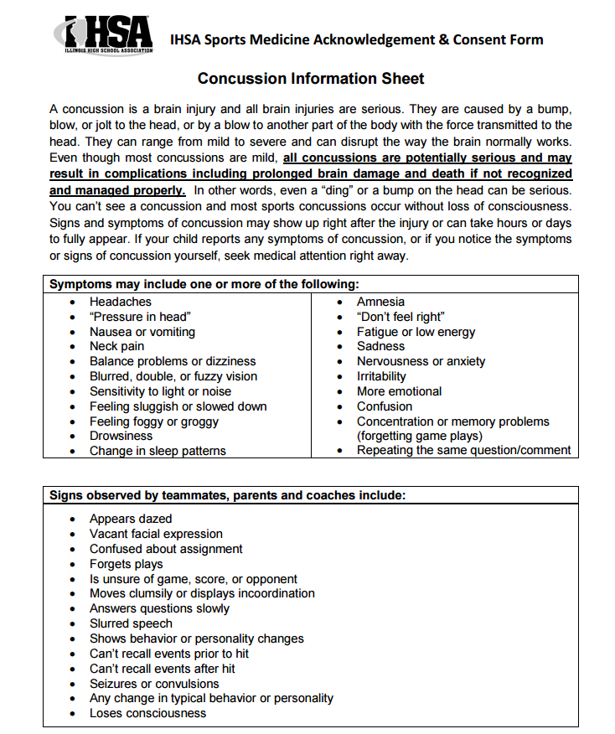
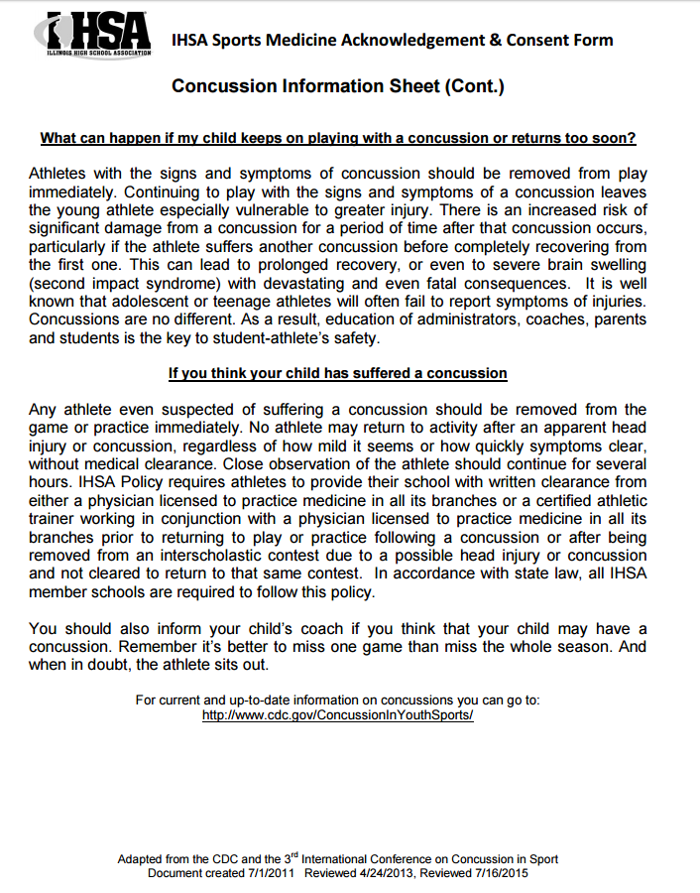
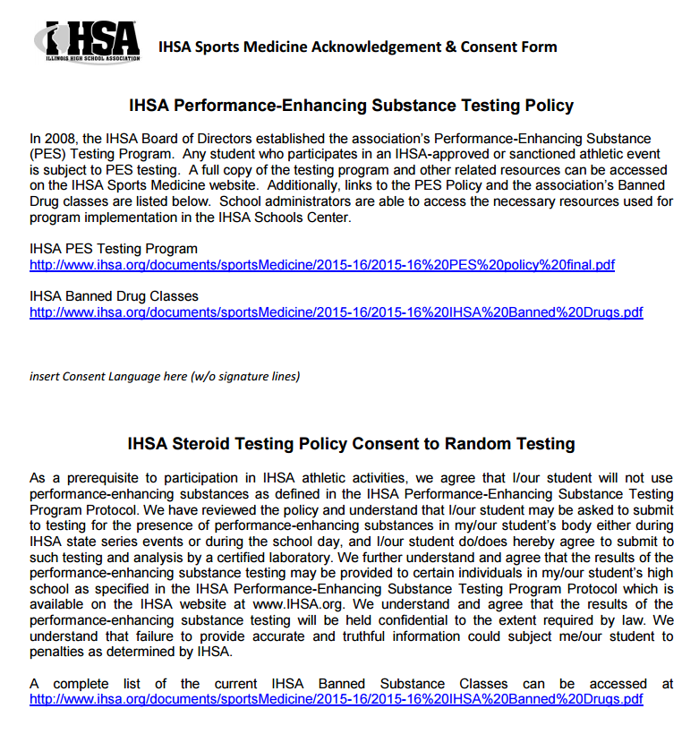

Flora CUSD # 35

Student Insurance Waiver

The Board of Education of Flora CUSD #35 offers accident insurance to cover students as well as student athletes during the school year. This coverage is not designed to be a primary coverage for a student and is designed to be an excess insurance coverage for athletes. While the District takes every precaution to ensure accidents and injuries do not occur, families and participants should have protection to cover the cost in case of such incidents. However, the District will not provide this same accidental injury coverage for athletes participating in summer programs and football season.

We urge you to read your health insurance policy very carefully and to review it with your insurance agent to be sure that you understand the coverage you have relative to sports accidents. Please be sure that you understand your policy. Please keep in mind that all expenses incurred as a result of athletic injuries are the responsibility of the parents.

By signing this handbook, I agree that I understand and accept full responsibility for medical expenses incurred as a result of my child's athletic participation in football and summer programs/camps at school.

_______________________________ _______________________________
Name of Athlete Health Insurance Provider

_______________________________ _______________________________
Parent Signature Date

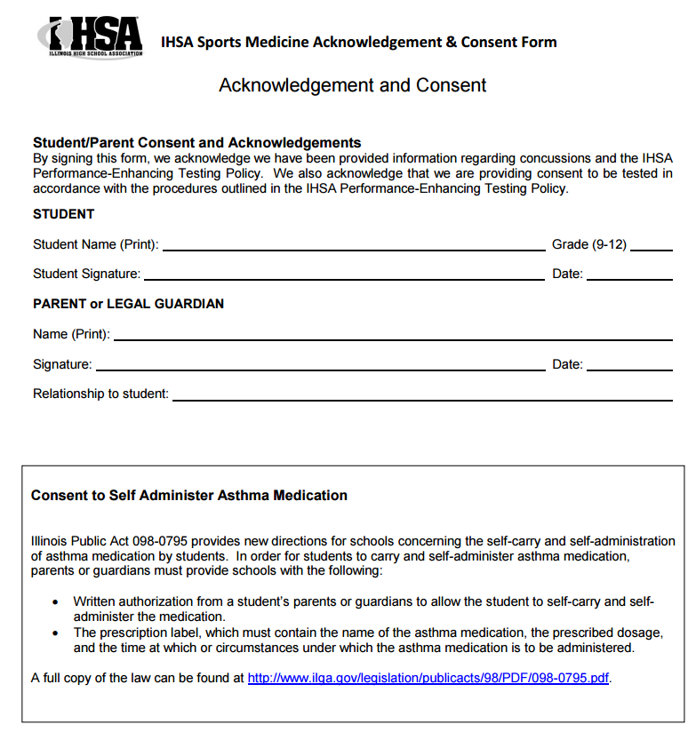

STUDENT ATHLETIC CONTRACT
I,___________________________________________________, while a participant in
athletic activities, promise to:
1. Attend all practices and meetings faithfully.
2. Contact a coach personally before the practice or meeting if I must miss it.
3. Faithfully attend all competitions in uniform,
4. Contact a coach or athletic director personally if I am unable to attend a competition.
5. Be a resident of the school district and full-time student.
6. Maintain my eligibility and academic standing.
7. Fully commit to the sport in season.
8. Be well-groomed, especially at competitions.
9. Refrain from using drugs, alcohol, tobacco products and inhalants.
10. Replace any equipment or uniform issued to me, either by payment or the equivalent of the lost
article.
11. Submit all the necessary forms issued to me by the coach or athletic director before the first
practice.
12. Report any personal injury or teammate’s injury to a coach immediately.
13. Follow all reasonable requests made by the athletic director and coaches, especially those
involving practice, diet, rest and competitions.
I have read the Flora CUSD #35 Athletic Handbook and agree to abide by the statements contained within. I understand when participating on athletic teams that I am representing my school and community. Participation on any athletic team requires my signature and that of my parent or guardian. Please return this form to your coach.

________________________________ ____________________________________
Athlete’s Signature Parent/Guardian’s Signature

ATHLETIC DEPARTMENT
EMERGENCY INFORMATION AND PARENT CONSENT

Name_____________________Birth date__________________Age

Parent’s Name______________________Home Phone

Address______________________City________________Grade

Day Phone of Parents: Father______________________Mother

In an emergency, if the parents cannot be reached, notify:

Name__________________________ Phone_____________________

Family Doctor___________________ Phone_____________________

Known Allergies

Permission is hereby granted to the attending physician to proceed with any medical; or minor surgical treatment, and x-ray examination for the above-named student. In the event of an emergency arising out of serious illness, the need for major surgery, or significant accidental injury, I understand that an attempt will be made by the attending physician to contact me in the most expeditious way possible. If said physician is not able to communicate with me, the treatment necessary for the best interest of the above-named student may be given.

Permission is also granted to the Certified Athletic Trainer to provide the needed emergency treatment prior to the student’s admission to the medical facilities.

Parent’s Signature__________________________ Date

