FLORA WOLVES
10 Malachi Tolliver 6-3 12
15 Jacob Stanford 5-10 12
20 Lawson Spicer 5-10 11
22 Neil Young 6-3 11
23 Tyler Conrad 5-8 11
24 Garrett Patridge 6-1 10l
30 Trevor Johnson 6-1 11
32 James Harrell 6-2 11
33 Jadon Leib 6-4 10
34 Ethan Redenbo 6-3 12
40 Quinn Uebinger 6-2 11
42 Ethan Durre 5-10 12
50 Mason Miller 6-4 12
53 James Mitchell 6-5 12
54 Jeffery Mitchell 6-4 12
55 Riley Bullard 5-10 12

Superintendent - Dr. Joel Hackney
Principal - Toby Pearce
Assistant Principal/Athletic Director - Bob McNeely
Head Coach – Phil Leib
Assistant Coaches – Todd Countryman, Alan Tolliver, Owen Leib,
Jefery Gaither
Scorekeeper – Steve Lewis
Athletic Trainer - Will McAllister
Cheerleading Coaches – Anna Maloy, Mandy Thompson
Cheerleaders – Haley Wicke, Kamry Austin, Ella Borcherding, Arabella Kuhlig, Elise Duke, Andi Henson, Ella Cammon, Caitlin Klein, Briley Keach, Makenna Hackney, Maggie Scarbrough, Alexi Stork, Jebee Salmarin, Sydney Dawkins, Jayden Lewis
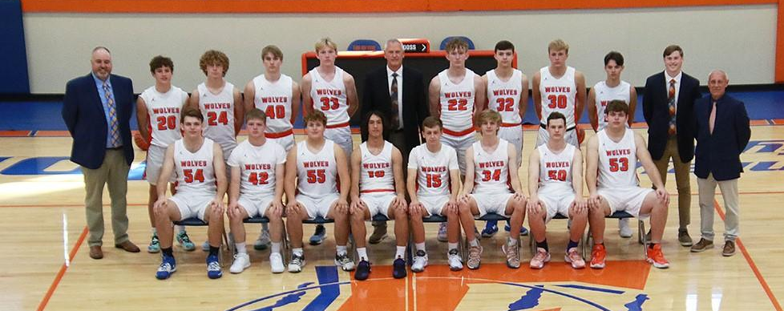
Front Row (L-R): Jeffery Mitchell, Ethan Durre, Riley Bullard, Malachi Tolliver, Jacob Stanford, Ethan Redenbo, Mason Miller, James Mitchell. Back row (L-R): Assistant Coach Todd Countryman, Lawson Spicer, Garrett Patridge, Quinn Uebinger, Jadon Leib, Head Coach Phil Leib, Neil Young, James Harrell, Trevor Johnson, Tyler Conrad, Assistant Coach Owen Leib, Assistant Coach Alan Tolliver

